CHAPTER II
REVIEW OF LITERATURES

Sample Topic Title (Level 3 heading – Major Topic)
This section discusses the features, capabilities, and limitations of existing research, Algorithm/s, Theoretical Framework and software applications that is relevant and closely related/similar to the proposed topic. The researchers can present their review of the literatures either in the chronological order or thematic
order.
At the end of this section, synthesis should be provided and should be concise, succinct, and brief reiteration of the major finds from the review of literatures. The researchers should summarize the contents of gathered Literatures and Studies and state also the relevant information to the research study. Related or similar applications or system can be also mentioned and discuss to establish the relevance of the study.
Minor Topic (Level 4 heading). You may use level 4 headings in discussing topics under a major topic. The topic title is in bold face.
Minor Topic (Level 5 Heading). You may use level 5 headings in discussing topics under a minor topic. The topic title is italicized.

Topical Outline
Develop a topical outline that categorizes the literature into main themes or topics, each representing a key aspect of your subject area. This outline will serve as a roadmap for your review, guiding the logical flow of your discussion. Arrange the topics in a manner that builds upon each other, highlighting how different studies relate and contribute to the overall understanding of the research area. Sample Topic Outline as shown below.
Sample Topical Outline for Literature Review on AR for Education

I. Introduction to Augmented Reality in Education
- Definition and overview of Augmented Reality (AR)
- Evolution and technological advancements in AR
- Rationale for using AR in educational settings

II. Applications of AR in Educational Contexts
- AR in primary and secondary education
- AR in higher education and professional training
- AR for special education and inclusive learning

III. Benefits and Advantages of AR in Education
- Enhancing student engagement and motivation
- Improving understanding of complex concepts through visualization
- Promoting active learning and interactivity
- Facilitating remote and distance learning

IV. Technological Components and Development of AR Applications
- Hardware requirements (smartphones, tablets, AR headsets)
- Software platforms and tools for AR development
- User interface and interaction techniques

V. Challenges and Limitations
- Technical challenges (hardware limitations, stability issues)
- Cost and accessibility concerns
- User acceptance and usability issues
- Ethical and privacy considerations

VI. Evaluation and Effectiveness of AR in Education
- Methodologies used in assessing AR-based learning outcomes
- Empirical studies and findings
- Case studies demonstrating success or failure

VII. Future Trends and Research Directions
- Integration with other emerging technologies (AI, VR)
- Personalization and adaptive learning through AR
- Scalability and widespread implementation
- Potential impact on future educational paradigms

Chronological Literature Review
When writing a chronological literature review, organize your sources in the order they were published to illustrate the development of research in your field. Start by introducing the earliest studies, highlighting their key findings, and then progressively discuss more recent work, noting how theories, methodologies, or technologies have evolved over time. This approach helps readers understand the historical progression and milestones within the topic.
Example of Chronological Review. In the early 2000s, research in intrusion detection systems primarily relied on signature-based methods, which could effectively identify known threats (Smith, 2002). As network complexities increased, researchers shifted towards anomaly-based detection techniques (Johnson, 2005), aiming to identify unknown attacks. The advent of machine learning introduced new paradigms, with studies like Lee (2010) applying supervised learning algorithms to improve detection accuracy. More recently, deep learning approaches, such as convolutional neural networks, have been employed to enhance real-time threat identification (Kim, 2018), reflecting technological advancements over time.

Thematic Literature Review
In a thematic literature review, organize your sources around key themes or concepts relevant to your research question. Group studies that address similar issues, theories, or methods, and discuss how each contributes to understanding that theme. This approach allows you to synthesize knowledge across studies and identify patterns, gaps, or contrasting perspectives within specific areas.
Example of Thematic Review. One prominent theme in cybersecurity research is the use of machine learning for anomaly detection. Many studies, such as Zhang (2015) and Patel (2017), have explored supervised algorithms like Support Vector Machines, demonstrating their effectiveness in identifying malicious network traffic. Conversely, others like Nguyen (2016) have focused on unsupervised techniques, such as clustering methods, which are particularly useful when labeled data is scarce. By comparing these approaches, researchers can assess the suitability of different models depending on the context and available data.

Methodological Literature Review
A methodological review categorizes existing studies based on the research methods employed. Describe and compare different approaches—such as experimental, simulation, case studies, or theoretical analyses—and evaluate their strengths and limitations. This helps highlight how methodological choices influence findings and suggests potential avenues for future research.
Example of Methodological Review. In IT security research, many studies utilize simulation environments to evaluate intrusion detection algorithms (e.g., Garcia, 2014), allowing controlled testing of system performance under various attack scenarios. Others rely on real-world data collected from organizational networks (e.g., Chen, 2016), providing practical insights but often facing challenges related to data privacy. Experimental setups, such as penetration testing, are also common for assessing system vulnerabilities (Kumar, 2018). Comparing these methodologies reveals that while simulations offer flexibility and repeatability, real-world data enhances ecological validity, emphasizing the importance of selecting appropriate approaches based on research objectives.

Summative Literature Review
A summative literature review provides a broad overview by summarizing key findings, themes, and trends across multiple studies. Focus on condensing information to highlight major contributions, common conclusions, and gaps in the literature. This approach is useful for establishing the current state of knowledge on a topic and identifying areas needing further investigation.
Example of Summative Review. Research in machine learning-based intrusion detection has advanced rapidly over the past decade. Studies consistently demonstrate that algorithms such as Random Forests and Support Vector Machines achieve high detection accuracy (Li, 2015; Ahmed, 2017). However, challenges remain in handling imbalanced datasets and reducing false positives. Furthermore, while deep learning models offer improved performance (Zhao, 2019), their computational complexity limits real-time deployment. Overall, the literature indicates a trend towards integrating multiple techniques to enhance detection capabilities, but standardization and scalability issues persist.

How to format Tables and Figures
You may add tables or figures in your discussion. Label of tables and figures are centered, bold and size 10. For tables, the label must be placed above the table while for figures it must be place below the figure. All tables and figures must be cited within the text. The word Figure must be used instead of figure or Fig when referring to the Figure. If figures are small, they can be arranged differently.
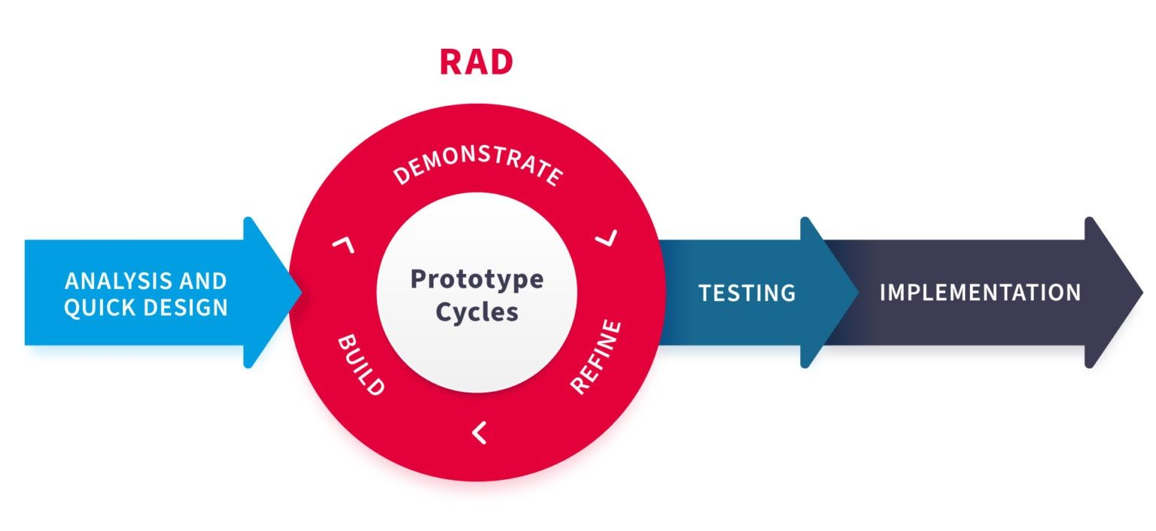
Source: Website Name/Article Name (if any)
Figure 1. Rapid Application Development

If a table or figure was taken from other literature, the source must be included and placed on the lower-left side of the Figure or Table.
Table 1. Sample Table
Regressor | Accuracy
Naïve Bayes | 80.75%
Logistic Regression | 87.63%
Support Vector Machine | 69.49%

All tables must be cited within the text. For example, Table 1 should be referred to as Table 1 and not table 1 or anything else. Font size for text within tables should normally be at 10 pt. If majority of the tables are small in width, they can be left-aligned but this must be consistent throughout the paper. Do not cut tables; try to fit the tables on one page. For long tables, summarize the data; highlight only important variables; or present the table in a landscape orientation on a single page.

Creating a Technology Gap Table
When creating a table and writing about a technology gap, identify areas where current solutions or methods fall short, are outdated, or lack efficiency, scalability, or security. Clearly articulate these shortcomings to highlight the need for further research or development. Your goal is to pinpoint specific issues that have not yet been addressed or areas where innovation is necessary. Use evidence from previous studies, market analysis, or industry reports to substantiate your claims. Structuring your paragraph to first describe the current state, then pinpoint the limitations, and finally emphasize the importance of addressing these gaps will make your argument compelling.
Table 1. Identified Technology Gaps in Websites with Predictive Analytics
Aspect | Current State | Gap/Limitations | Impact of Gap | References
Real-time adaptability | Basic models with periodic updates | Lack of real-time data integration | Reduced prediction accuracy and responsiveness | Johnson & Lee, 2021
Personalization | Generalized user predictions | Limited personalization per user | Lower user engagement and satisfaction | Smith, 2020
Machine learning integration | Use of traditional algorithms | Absence of advanced, self-learning algorithms | Decreased predictive precision over time | Kim et al., 2022

EXAMPLE. Despite the growing adoption of predictive analytics in website development, many existing platforms exhibit significant limitations. Most current websites utilize basic predictive models that rely on historical data to forecast user behavior, but they often lack real-time adaptability and personalized insights (Johnson & Lee, 2021). These systems primarily focus on general trends rather than individualized predictions, which reduces their effectiveness in enhancing user engagement (Smith, 2020). Additionally, many platforms do not integrate advanced machine learning algorithms that can continuously learn and improve from new data streams, limiting their predictive accuracy (Kim et al., 2022). Addressing these gaps by developing more sophisticated, real-time, and personalized predictive analytics systems could significantly improve user experience and business outcomes.

Creating a Literature Matrix
A literature matrix is a useful tool to organize and synthesize existing research relevant to your topic. To create one, start by identifying key studies, articles, or reports that address your research area. For each source, extract essential information such as the author(s), year of publication, research objectives, methodologies used, key findings, and limitations. Arrange this information into a table with clear columns for each category. This structured approach allows you to easily compare and contrast different studies, identify gaps in the literature, and justify your research focus. When compiling the matrix, aim for clarity and conciseness, focusing on how each source contributes to understanding the current state of the field.
EXAMPLE. Studies by Nguyen et al. (2019) and Patel (2020) have explored the integration of geospatial data with web platforms for urban planning, highlighting the potential for real-time mapping to improve decision-making. However, these studies often focus on specific applications, such as disaster management or transportation, and tend to use limited datasets, which restricts their generalizability. Other research, like that of Lee and Kim (2021), has examined the technical challenges of integrating GIS technologies with web interfaces, noting issues related to data accuracy and user interaction. By organizing these studies into a literature matrix, researchers can clearly see the progression of geospatial mapping applications and identify gaps, such as the need for more user-friendly interfaces and scalable data solutions, that future research can address.
Table 2. Literature Matrix
Author(s) & Year | Research Objectives | Methodology | Key Findings | Limitations | References
Nguyen et al., 2019 | Explore real-time geospatial data in urban planning websites | Case study with GIS integration | Improved decision-making with real-time maps | Limited geographic scope, small datasets | Nguyen et al., 2019
Patel, 2020 | Assess web-based geospatial tools for disaster management | Comparative analysis of platforms | Enhanced situational awareness | Focused on specific disasters, limited user testing | Patel, 2020
Lee & Kim, 2021 | Investigate technical challenges of GIS-web integration | Technical review and user testing | Data accuracy and interface issues identified | Limited scalability, user experience concerns | Lee & Kim, 2021

Other Tips for Writing Literature Review (PEEL and STRIP methods)
PEEL and STRIP are structured methods used to organize and develop paragraphs in a literature review, helping writers present and analyze research findings clearly and effectively.
PEEL. The PEEL method is a useful framework for constructing clear and analytical paragraphs within a literature review. It encourages writers to start with a clear point or topic sentence that introduces the main idea of the paragraph. This is followed by presenting evidence from relevant studies, such as research findings or theoretical insights, to support the point. The explanation then interprets the evidence, discussing its significance and how it relates to the research topic. Finally, a link ties the paragraph back to the overall research aim or transitions smoothly to the next point, ensuring coherence and logical flow throughout the review. By following the PEEL structure, writers can create well-organized and persuasive paragraphs that effectively synthesize existing literature. PEEL stands for:
Point: State the main idea or argument of the paragraph.
Evidence: Provide supporting evidence from literature (e.g., research findings, quotes).
Explain: Analyze or interpret the evidence, explaining its significance.
Link: Connect the paragraph back to your overall research question or to the next point.
Example.
- Point: Many studies highlight the importance of real-time data in geospatial mapping websites.
- Evidence: Nguyen et al. (2019) demonstrated that real-time updates significantly improve urban planning decisions.
- Explain: This suggests that integrating live data enhances the relevance and usefulness of geospatial platforms for city managers.
- Link: Therefore, incorporating real-time features is crucial for the effectiveness of such websites, which aligns with our focus on improving user engagement.

STRIP. The STRIP method offers a structured approach to developing focused and comprehensive paragraphs in a literature review. It begins with introducing a sub-topic that narrows down the specific aspect being discussed, followed by a clear topic sentence that states the main idea of the paragraph. The writer then incorporates research evidence, such as studies or data, to support this idea. An analysis or discussion of the implications of this evidence comes next, explaining its relevance or impact on the research area. Lastly, a link connects the paragraph's content to the broader research context or prepares the reader for the next section. Using STRIP helps ensure each paragraph is purposeful, coherent, and contributes meaningfully to the overall synthesis of literature, facilitating a logical and organized review process. STRIP stands for:
Sub-topic: Introduce the specific aspect or sub-topic being discussed.
Topic sentence: Present the main idea or focus of the paragraph.
Research evidence: Include relevant studies or data supporting this idea.
Implication: Discuss the significance or implications of this evidence.
Link: Connect back to the main research question or the next section.
Example.
- Sub-topic: User interface design is vital for effective geospatial mapping websites.
- Topic sentence: A user-friendly interface increases accessibility and user satisfaction.
- Research evidence: Lee and Kim (2021) found that complicated interfaces deter user engagement.
- Implication: Simplifying interface design could lead to higher adoption rates and better data utilization.
- Link: This highlights the importance of usability in developing successful geospatial web platforms.

Synthesis
This is the portion of the Review of Literature that presents the relationship of the present study to the investigations being reviewed. It summarizes and emphasizes its relevance to the current study. Also, it presents the related studies and related systems the researchers found out. The researchers can also present a technology gap analysis table to be able to justify the gap to be filled in. a table of algorithm matrix can be presented to support the choice of algorithm if applicable to the study.

